[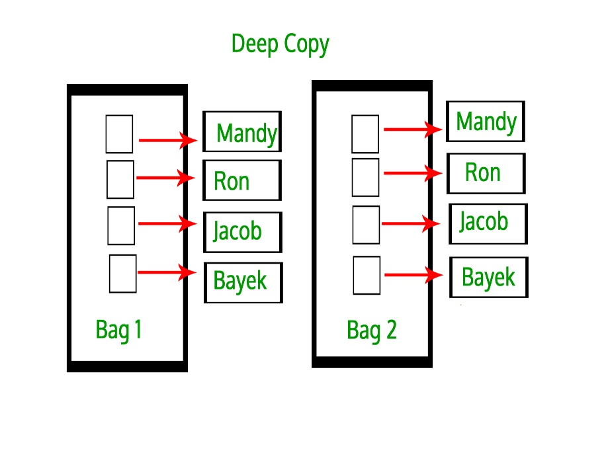](https://media.geeksforgeeks.org/wp-content/uploads/deep-copy.jpg)

[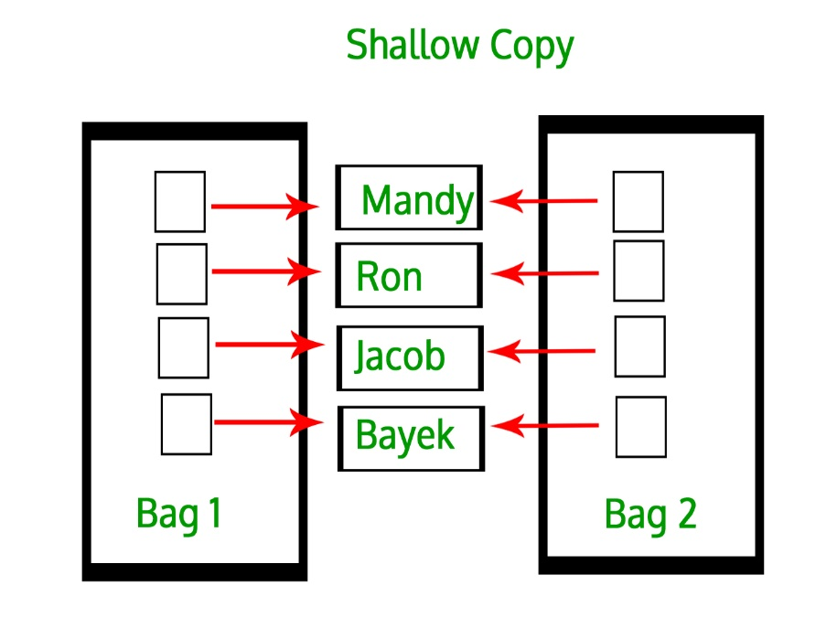](https://media.geeksforgeeks.org/wp-content/uploads/shallow-copy.jpg)